Evaluating Deep Neural Network for Automated Sleep Staging in Real Life Scenarios

Dailun Li 1st Affiliation
Faculty of Computer Science
McGill University
Montreal, Quebec, H3A0G4, Canada
dailun.li@mail.mcgill.ca

Abstract — Using artificial intelligence (AI) in automated sleep staging has become very popular. In this paper, we introduce a deep learning model, Tiny Sleep Net to help realize the automated sleep staging, as well as evaluating the performance of this model which contains two layers of convolutional neural network (CNN) as well as one layer of Long-Short-Term Memory (LSTM). During the experiment, we changed the hyperparameter to achieve various study rates, changed the number of epochs, as well as the balance of datasets. The results showed that the original result of this model is quite acceptable, which is 82.3%, while the whole model is relatively fragile when some parameters are changed, witnessing an incredibly low accuracy when predicting. In addition, compared with the overall accuracy, the difference in the per-class accuracy can be drastic. Therefore, these results showed that our approach is highly sensitive to the hyperparameter as well as the exact number of epochs generated. Therefore, in exact situations, when the input dataset is not balanced, or hyperparameters have minus changes, the final prediction accuracy will decrease dramatically. Considering this property, the approach in our essay requires further improvement to better fit the real situations.
Keywords-component; formatting; style; styling; insert (key words)

Introduction
An electroencephalogram (EEG) is a test that detects electrical activity in human brains using small, metal discs (electrodes) attached to the scalp. Brain cells communicate via electrical impulses and are active all the time, even during sleep. This activity shows up as wavy lines on an EEG recording [4].

EEG recording during sleep can be divided into four stages, N1, N2, N3, and Rem, N1 is essentially the "dozing off" stage, during N1 the body has not fully relaxed, though the body and brain activities start to slow with periods of brief movements (twitches), it usually lasts one to five minutes. N2 is the stage the body enters a more subdued state including a drop in temperature, relaxed muscles, slowed breathing, and heart rate. At the same time, the brain waves show a new pattern and eye movement stops. N3 is also known as deep sleep, it is hard to wake someone up if they are in this phase, pulse and breathing rate decrease as the body relaxes even further. Rem is the phrase that brain activity picks up, nearing levels seen when you are awake. we label EEG recording that is out of sleeping stages as "wake", so we have five stages in total to define EEG recording (Wake, N1, N2, N3, Rem).

In recent years, the use of the deep learning model in scoring sleep stages has aroused great attention. These models extracted various signals such as EEG, EMG, EOG, and even heart rate. In comparison, the method that models build upon are converged into the following steps. First, the stream of waves is converted from the time domain to the frequency domain. Then the features are then merged and labeled into multidimensional vectors. Afterward, such vectors are trained by passing into the neural networks to build up the model and optimizing the edge of different classes. Nowadays, one popular approach for sleep stage scoring and hypnogram determination is Convolutional Neural Networks. Having acknowledged that the deep learning networks are formulated and considered one of the most feasible approaches in automated sleep staging fields, we still recognize the limitations that could be brought by deep learning networks [5]. Among various researches, one deep learning model (TinySleepNet) proposed by Guo and Akara [1] appeared to have a satisfying outcome. However, whether using deep learning models is efficient has long been a controversial issue. In one research conducted by Su, Vargas, and Sakurai [6], the deep neural network was proved to be losing effectiveness when one pixel is modified manually. Specifically, as for deep learning models analyzing EEG signals, Wu and Zhang [7] also claimed the vulnerability of one particular kind of classifier, CNN.

Therefore, being inspired by the idea that the deep learning network may be significantly affected when some parameters or some other aspects witness modification, we suppose that the model Tiny Sleep Net which uses the approach of CNN combined with LSTM may also encounter similar problems. Therefore, in this paper, we investigated the performance of Tiny Sleep Net in automated sleep staging as well as the actual sensitivity of this model to the amount of dataset as well as the hyperparameters. To achieve this goal, we changed the dataset amount various times, while changing the hyperparameter several times as well. With the final output achieved, further analysis was conducted.

The rest of this paper is organized as follows. Section 2 gives an overview of the proposed methods including Deep Sleep Net deep learning model that automatically score sleep stage according to raw single-channel EEG [9] which is different from some solutions that analysis and extract features from EEG manually, Section 3 shows the experimental results and prediction accuracy based on the test we ran on the model. Section 4 indicates the improvements we further expected for this model to be pragmatic and the reason why such model is relatively less reliable to be implemented in practice. Section 5 is the overall conclusion of this experimental analysis, with a succinct description of the relationships interpreted in the previous sections.

Methodology
In this paper, we used a typical model, which is the combination of CNN and LSTM, called deep sleet net. Based on this model, we evaluated the sensitivity of this model by modifying the hyperparameters as well as the number of datasets multiple times, followed by the various comparison of the outer performance under different circumstances.
This model includes two parts, first one is representation learning which can be trained to extract time-invariant features from each of raw single-channel EEG epochs, The second one is sequential residual learning, which can be trained to encode temporal info from a list of EEG epochs in the extracted features.
Representation learning, in this part the model includes CNNs with small and large filter sizes at the first layer which extracts time-invariant features from raw single-channel 30s epoch, each CNN includes four convolutional layers and two max-pooling layers, each layer performs three operations: 1D-convolution, batch normalization, and applying the rectified linear unit activation, Formally, suppose there are N 30-s EEG epochs from single-channel EEG. We use the two CNNs to extract the i-th feature from the i-th EEG
Equation 1
Equation 2
Equation 3

CNN is the Function that transforms 30s EEG epoch into feature vector h, ‘||’ is concatenate operation that combines two outputs together.

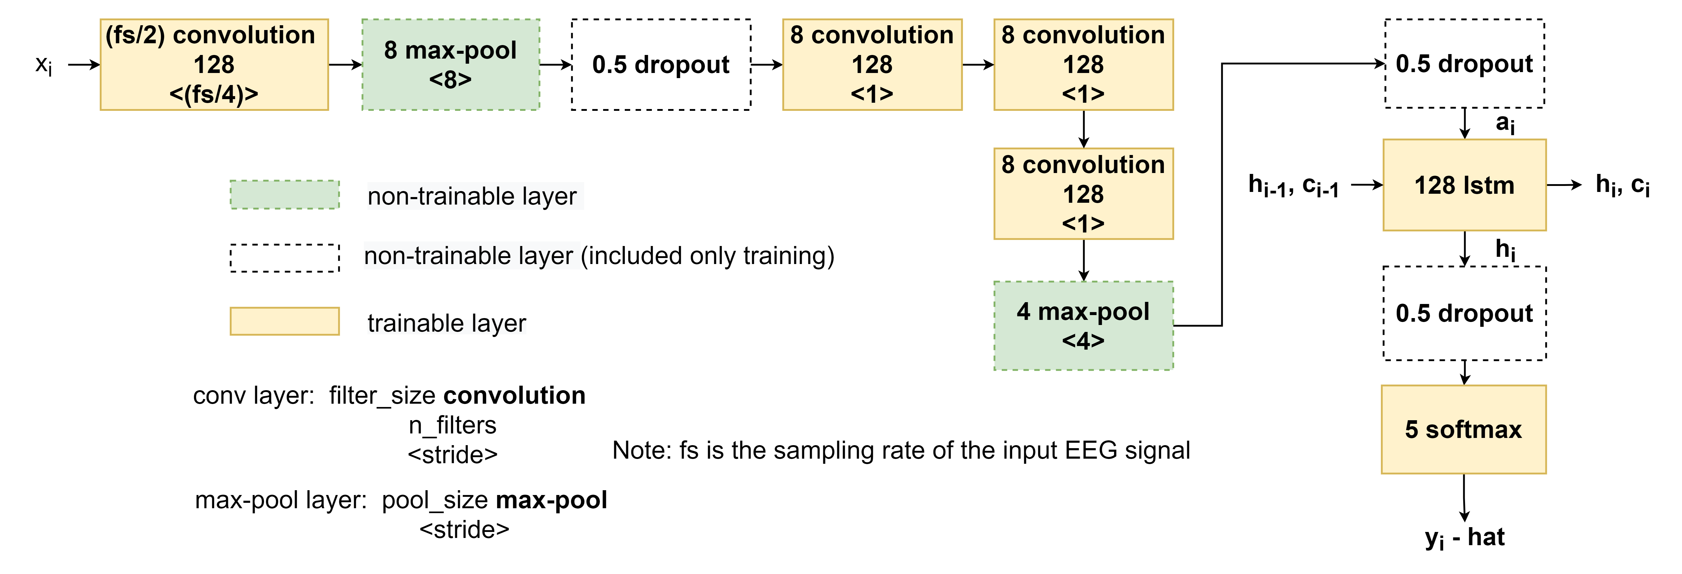
Fig. 1 Diagram of CNN
Sequential Residual Learning, this part includes bidirectional-LSTMs [10] and a shortcut connection, we use two bidirectional-LSTM layers to learn temporal info which the sleep expert can use to determine next possible sleep stages based on previous stages. For example, the AASM manual said that if a subject is in sleep stage N2, continue to score epochs with low amplitude and mixed frequency EEG activity as N2 even though K complexes or sleep spindles are not present, so that LSTM can learn to remember that is has seen the stage N2, and continue to score next epochs as N2 if they still detect the low amplitude and mixed frequency. shortcut connect is used to reformulate the computation of this part into a residual function. this allows our model to add temporal info it learns from the previous input sequences into feature extracted from the CNNs. we also use fully-connected layer to transform the features from the CNNs into vector that can be added to the output from the LSTMs. This layer performs matrix multiplication with its weight parameters, batch normalization and applying the ReLU activation sequentially. Formally, suppose there are N features from CNNs arranged sequentially and t = 1...N denotes the time index of 30-s EEG epochs, our sequence residual learning is defined as follow:

Equation 4
Equation 5
Equation 6

LSTM represents function that processes sequences of features using two-layers LSTM parameterized by theta f and theta b for forward and backward directions, FC represents a function that transform features 'at' into a vector that can be added (element-wise) with the concatenated output vector from the bidirectional-LSTM

experimental results and analysis
The dataset was provided by physionet Error: Reference source not found, it contains sleeping stage EEG and ECG recording from subjects over the past few decades. This dataset and labels are collected from various environments and labeled by professional experts, with each signal being sampled at 100Hz. There are both balanced inputs and unbalanced inputs that can be derived from the pool of EEG signals, but overall the dataset involves the least amount of N1 signals, whereas the N3 signals occupy most of the data inputs. Each of the recordings is segmented into a 30s epoch, and the labeled hypnogram is separately saved, The real detected data are saved as EDF files that can be viewed using “pyedflib”. These EEG signals were collected from Fpz-Cz and Pz-Oz locations. In our model, we have two CNNs with four convolutional layers and two max-pooling layers, and they are used to detect temporal and frequency information from EEG. The model is separately trained for 20 folds, each consists of 40250 streams of signals, with each fold contains 30, 50, 100 epochs for three different training approaches. For each neural network, the minimum loss function is calculated based on the Adam algorithm, where the step length is only dependent on learning rate, beta1, beta2. The initial learning rate is set to (mark as trial 1), (mark as trial 2 ), (mark as trial 3), and the beta1, beta2 are set to 0.9 and 0.999 by default, and epsilon of the adam's algorithm is set to . In addition, an autodetection of early stopping with a checking span of 20 epochs is applied. In this case, the training process of one-fold will stop if the F1 scores of the last 20 epochs are not explicitly increased. After the optimized hyperparameters are generated, we also include a list of balanced and unbalanced data inputs to verify whether the predictions are affected by the distribution of data inputs or not.

Result of the training process:
Table of the final training output
epoch | time (s) | n | loss | accuracy | F1
191 | 30.88 | 40250 | 0.438 (0.038) | 0.160 | 0.138
192 | 30.73 | 40250 | 0.438  (0.038) | 0.161 | 0.138
193 | 31.01 | 40250 | 0.438 (0.038) | 0.162 | 0.140
194 | 31.26 | 40250 | 0.438 (0.038) | 0.161 | 0.139
195 | 30.75 | 40250 | 0.438 (0.038) | 0.163 | 0.140
196 | 30.93 | 40250 | 0.438 (0.038) | 0.160 | 0.138
197 | 31.00 | 40250 | 0.437 (0.038) | 0.161 | 0.139
198 | 31.06 | 40250 | 0.437 (0.038) | 0.161 | 0.138
199 | 30.99 | 40250 | 0.437 (0.038) | 0.161 | 0.138

Table of the valid time
epoch | time (s) | n | loss | accuracy | F1
191 | 1.73 | 2000 | 0.438 | 0.096 | 0.076
192 | 1.73 | 2000 | 0.438 | 0.096 | 0.076
193 | 1.74 | 2000 | 0.438 | 0.096 | 0.076
194 | 1.73 | 2000 | 0.438 | 0.096 | 0.076
195 | 1.75 | 2000 | 0.438 | 0.096 | 0.076
196 | 1.76 | 2000 | 0.437 | 0.096 | 0.076
197 | 1.75 | 2000 | 0.437 | 0.096 | 0.076
198 | 1.73 | 2000 | 0.437 | 0.096 | 0.076
199 | 1.75 | 2000 | 0.437 | 0.096 | 0.076

In trial 1 and trial 2, the initial learning rate with and tend to not express the relationship at all: both the training and validating accuracy appears constant at a random level, with similarily unfluctuating F1 scores. This constant accuracy and F1 score [13],[14] imply that the gradient function does not converge to a global or local minimum. Such two changes in the hyperparameters revealed unachievable.
During the trial 3 training process, the accuracy of the first 17 epochs is not at an acceptable level since the constraints of our training datasets cannot be ignored. When model optimize the validation set with a more in-depth and developed amount of data samples, the performance increased dramatically, as a significant decrease in losses is observed. Figure 4.2 is an example of the cross-validation accuracy outputted by the model with hyperparameters listed in trial 3.

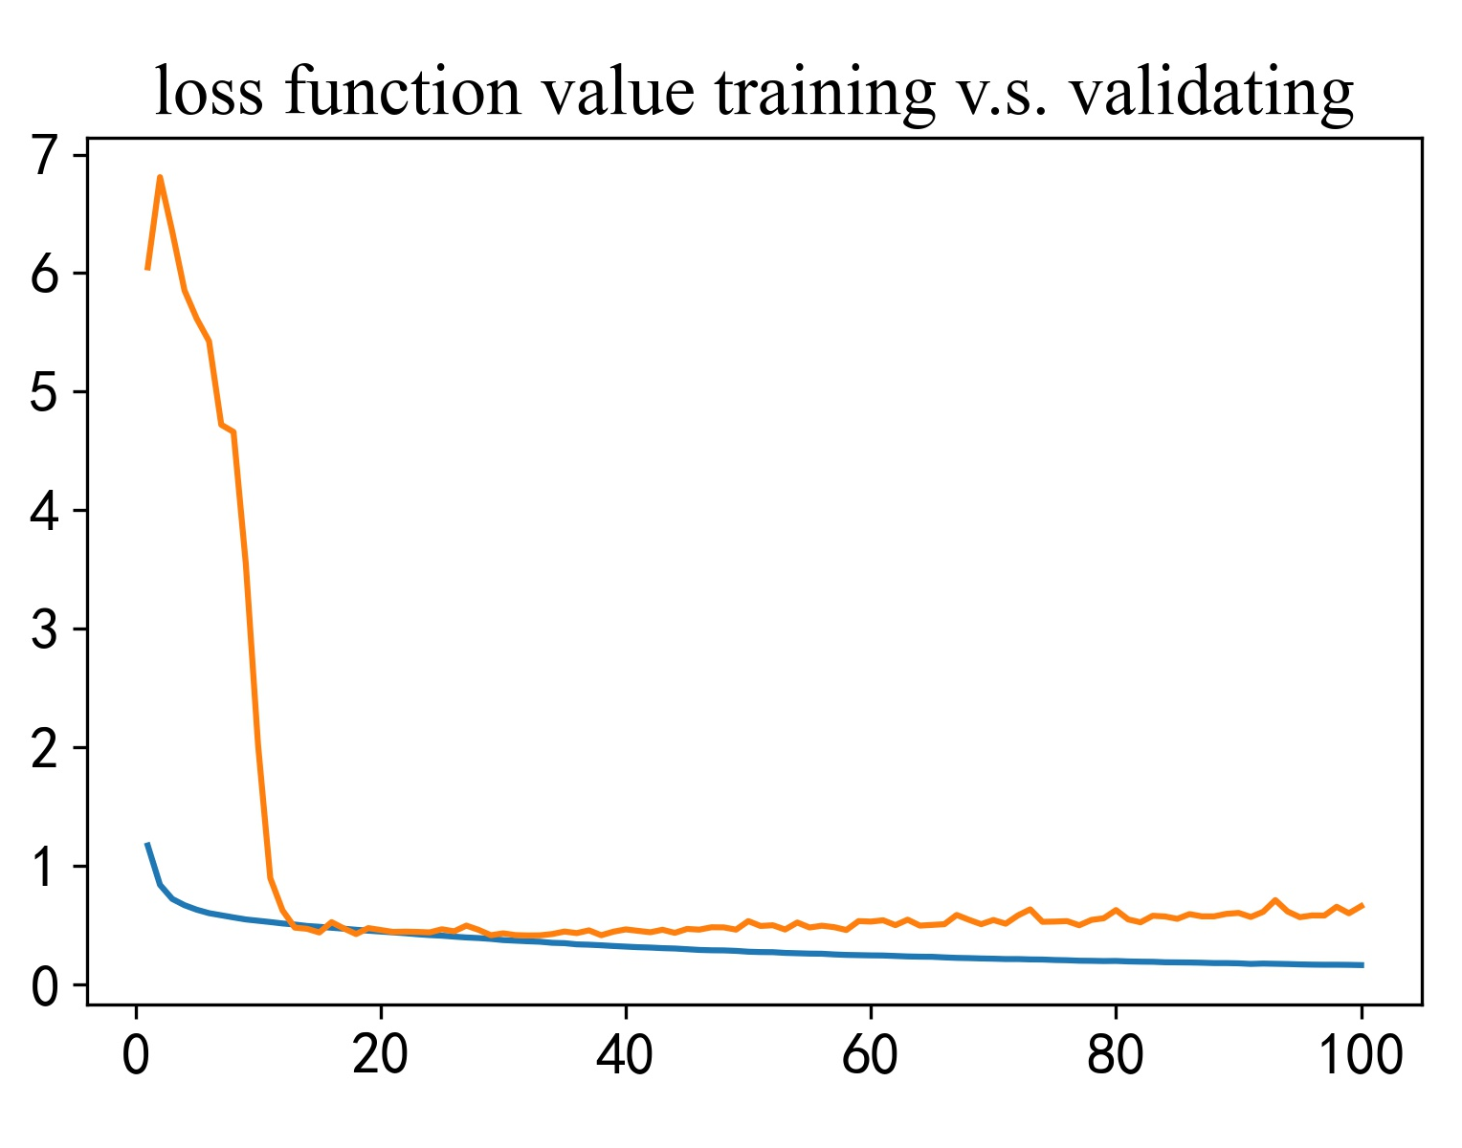
Figure 4.1 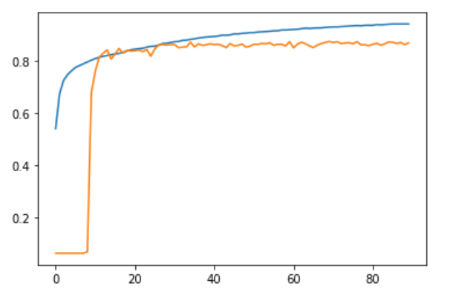
Figure 4.2

Since the accuracy of validating the dataset fluctuates whereas testing dataset performance progresses, one can expect the cumulative loss function to be quite different. When the general features are not clarified in our datasets, the loss of our model increases and decreases dramatically. In addition, compared to the dataset of our epochs (40250), a dataset with (2000) epochs has a chance to cause an imbalance in the chosen data which may affect our predictions. Till the first 20 classes have proceeded, the loss function of our testing set becomes steady and normal.

Output Analysis
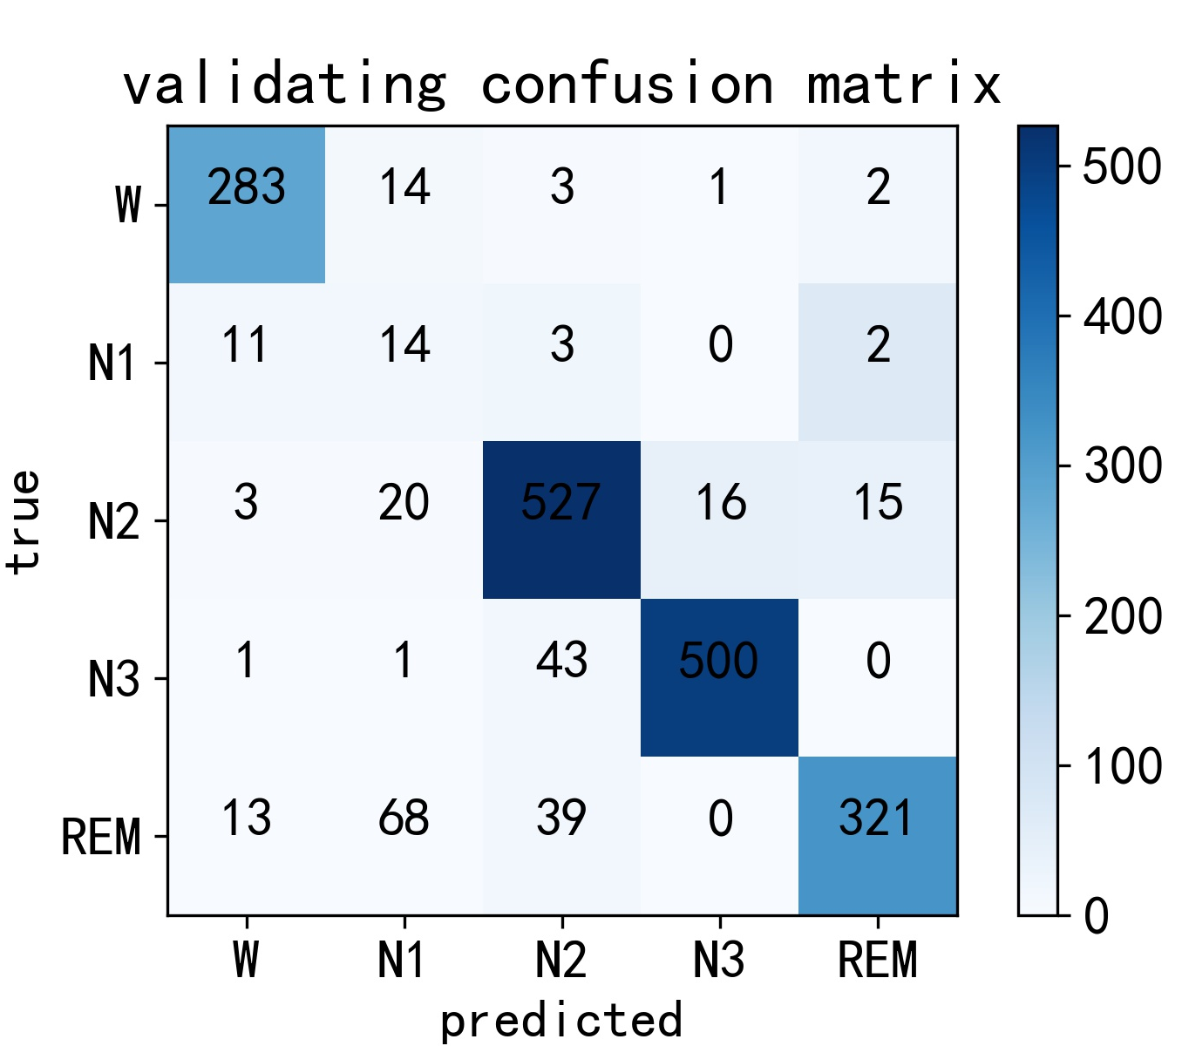
Figure 5.1

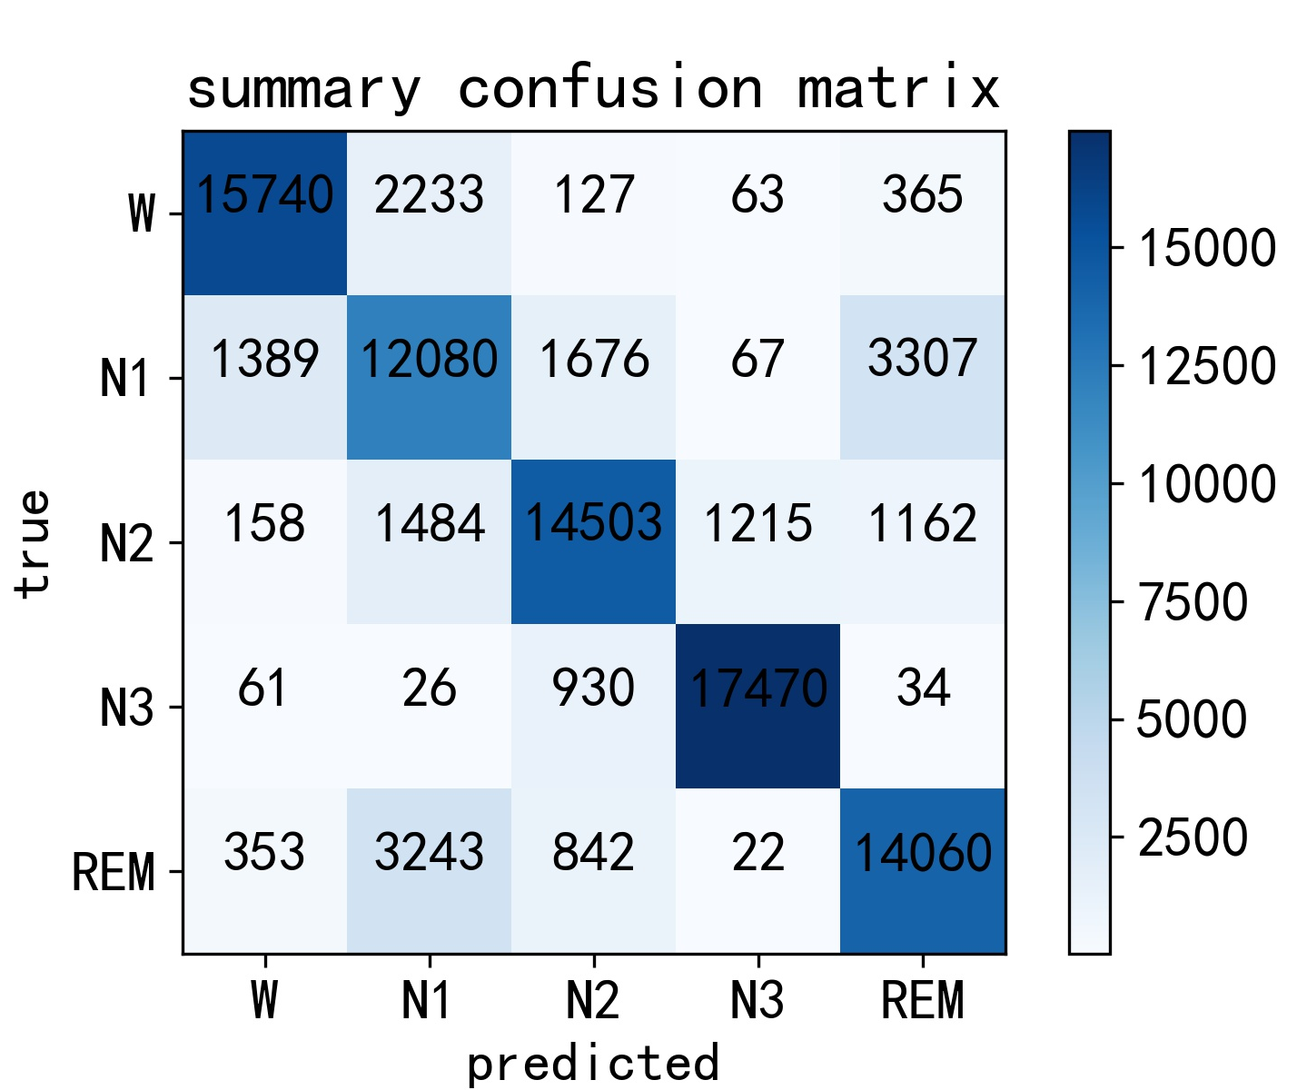
Figure 5.2

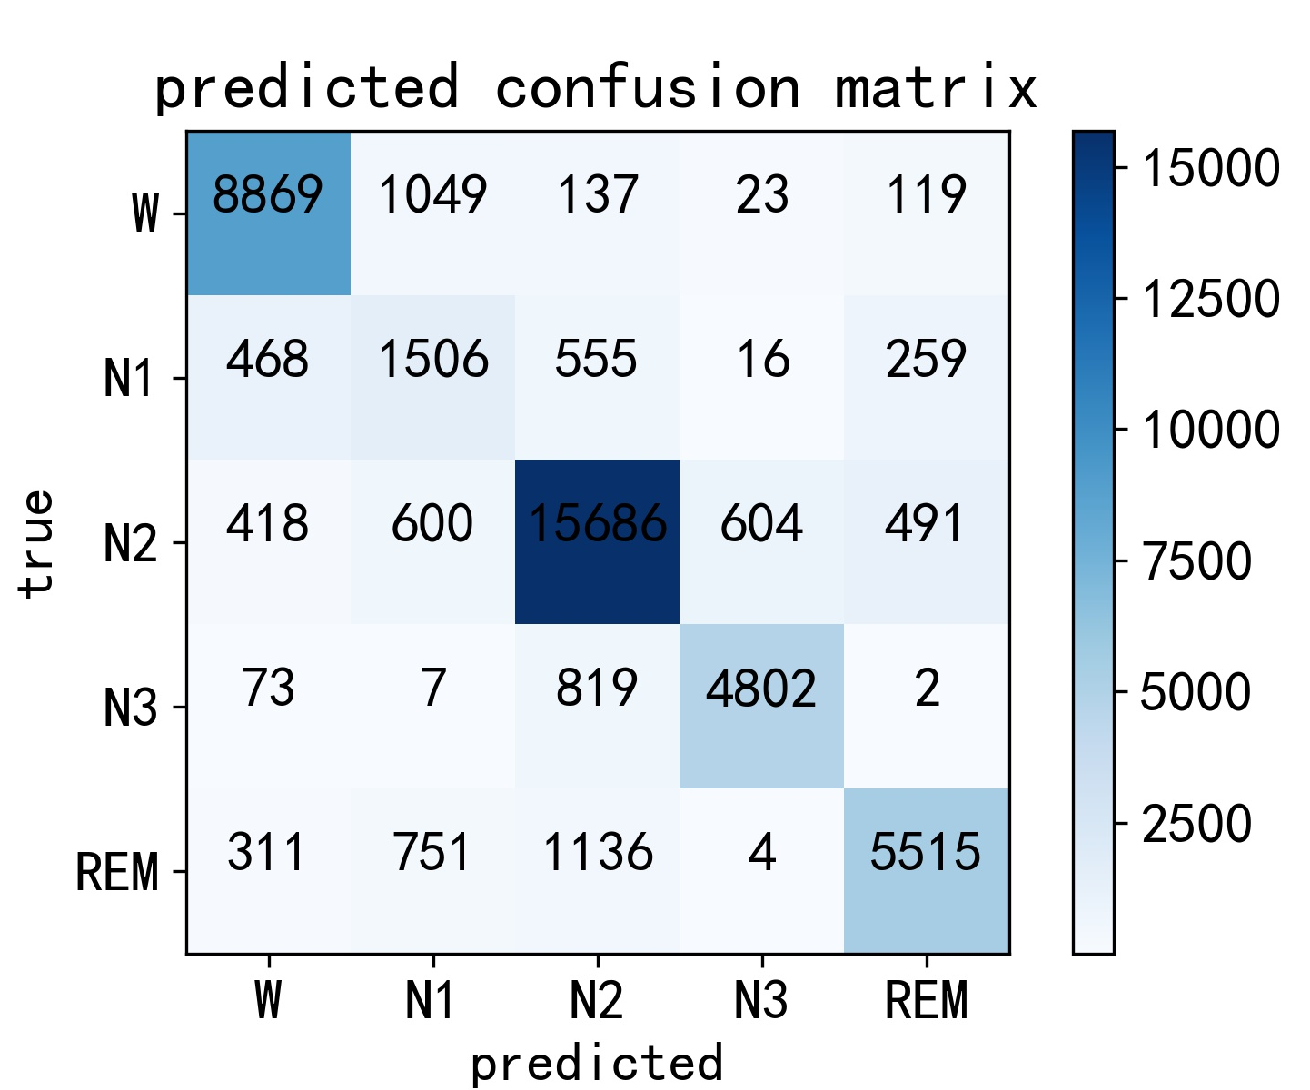
Figure 5.3

The above is a confusion matrix we used for validation: One important issue that cannot be ignored is that because of the lack of the N1 stage data inputs, the accuracy considered merely the TP of N1 stage is not well detected. This incident exists when one of the data entries occupies less than 3% of the total number of epochs. Thus, during the max pooling process, some features dropped from the N1 stage are more sensitive compared with other sleep stages which further affect the detection of the N1 stage. Figure 5.1 shows a result of unbalanced inputs resulted in a problem in minority data determination. In contradictory, we also included Figure 5.2 in comparison, which consists of relatively balanced inputs. This case, the darkness of the diagonal entries of the matrix shows a better prediction on not only the overall accuracy but also, specifically, the N1 labels.
F1 score is directly calculated from components of True positive, True negative, False positive and False negative, and is widely used in evaluating the performance of a particular model.
The table of F1 score
F1 score | predicted True | predicted False
prelabelled True | True positive (TP) | False negative (FN)
prelabelled False | False Positive (FP) | True negative (TN)
F1 score is directly calculated based on (TP+TN) / (TP+TN+FP+FN)

The table of checkout points for various epochs
Checkout point | 30 epochs | 50 epochs | 100 epochs | 150 epochs | 200 epochs
checkpt Acc | 46.5 | 84.9 | 88.2 | 88.2 | 86.3
checkpt F1 | 29.7 | 75.1 | 83.1 | 82.7 | 81.1

The checkpoint accuracy (checkpt Acc) and checkpt F1 score (checkpt F1) is calculated by the first 5 folder's average accuracy and F1 score.
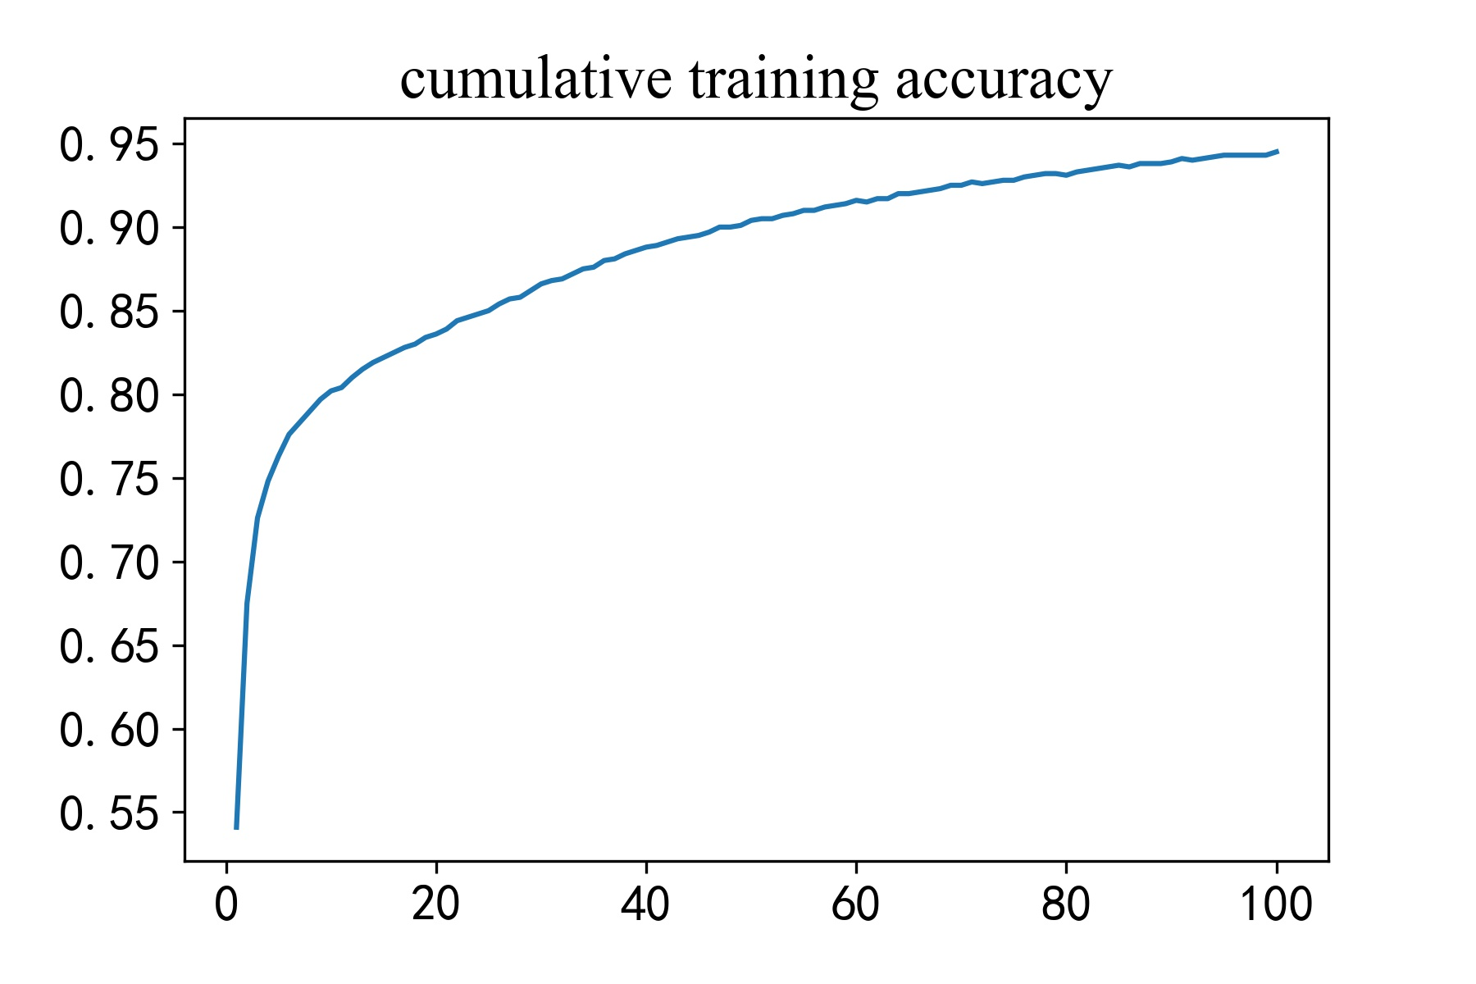
Figure 6.1
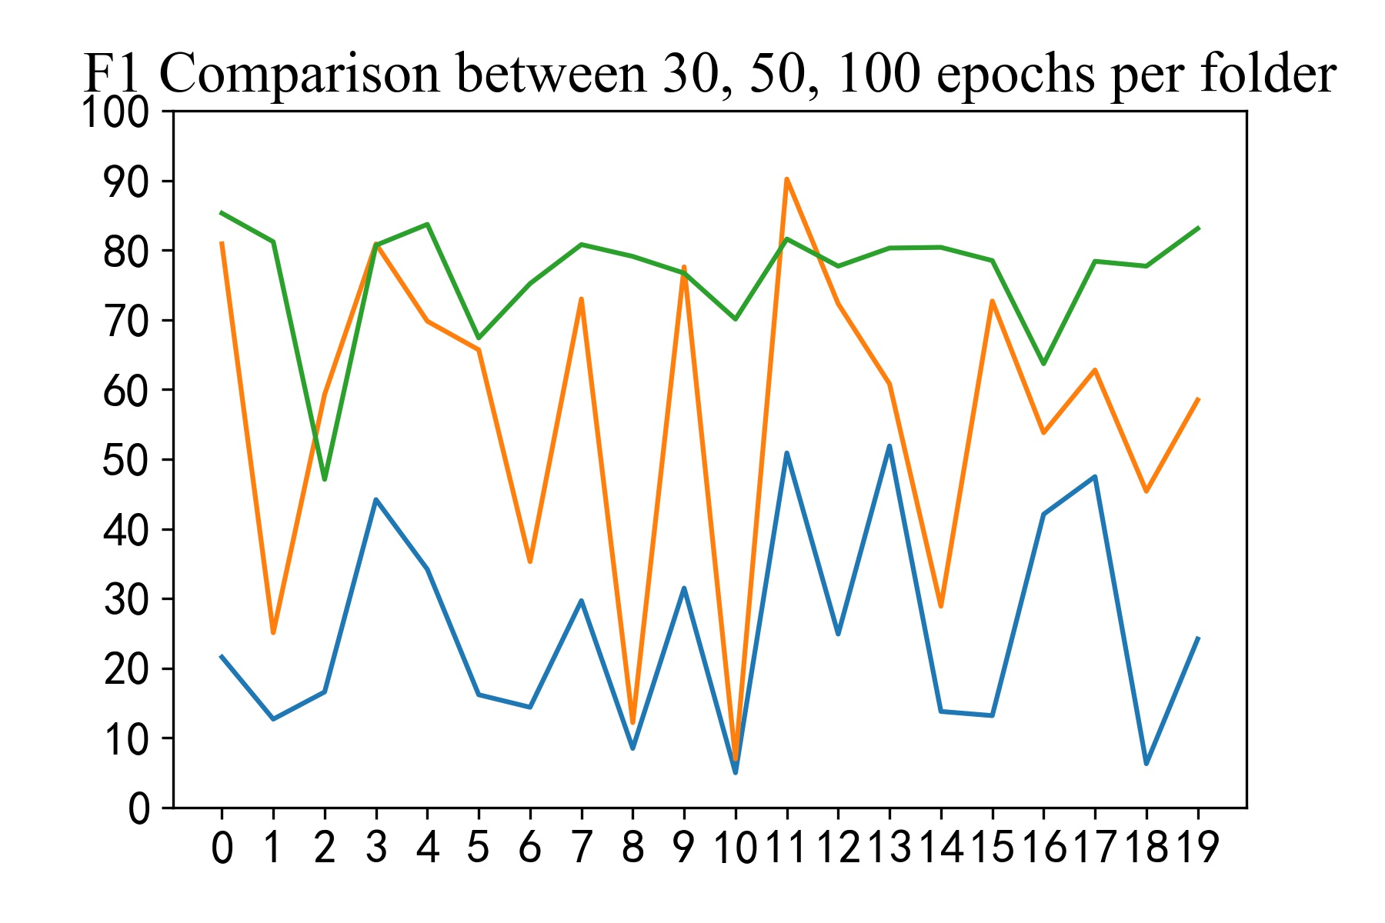
Figure 6.2
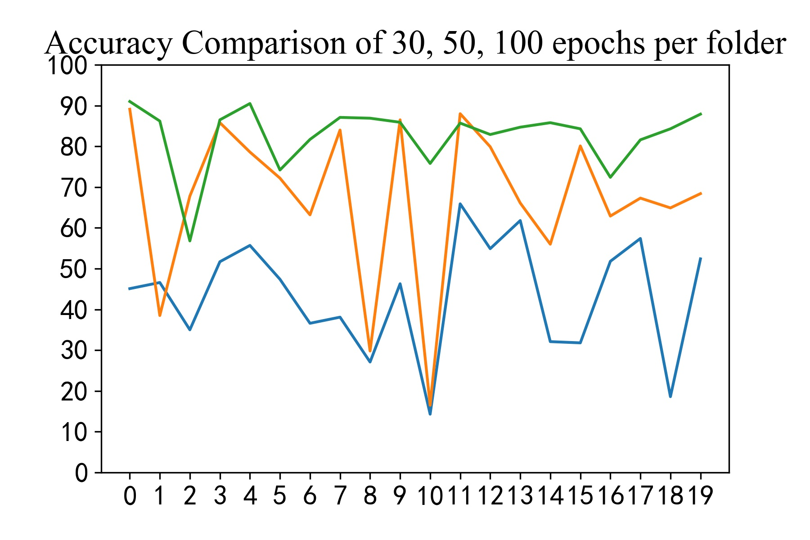
Figure 6.3

Figure 6.1 represents the F1 function value during training with 100 epochs: After removing the noises of our data, this is an example of our F1 function of one of our best training models, which, with the help of our self-adapted gradient descent method, indicates a fluent and steady learning process. It also presents that the F1 output has a long relationship with the number of epochs the network has proceeded.

We first run 200 epochs on the first five folders and analyze the trend by recording each checkpoint accuracy and F1 score, the mean of each data is then calculated to minimize the noise brought by occasional outliers. From the above data, we can conclude that after 100 epochs per folder, the accuracy and F1 score becomes stable, therefore we use 100 epochs per folder as our optimal approach.
Figure 6.2 and Figure 6.3 are indications of per folder F1 scores and accuracy scores collected during the prediction process. With the green line on the top refers to 100 epochs per table, the yellow and blue line refers to 30, 50 epochs per folder respectively. The accuracy and F1 score of blue lines are relatively low with an accuracy of 43.5% and an F1 score of 0.254, which shows that the 30-epoch-per-folder stops at a time that the gradient descendent process does not find a minimum of the loss function, thus the prediction is predominantly based on the randomly assigned weights. With the method of 50 epochs per folder, it demonstrates a fluctuating trend in both accuracy scores and F1 scores. This, to a large extent, provides us with the in-process determination of the global minimum of the loss function. However, the accuracy of the 8th and 10th folders remains at a randomized level, which states that the tendency of the correct weights is not yet determined. This particular amount of data outputs an average accuracy of 67.3% with an F1 score of 0.566. In comparison with the previous two approaches, when 100 epochs are trained in each folder, the output becomes relatively steady, with an average accuracy of 82.6 and an average per folder F1 score of 0.796. The above data clearly indicates that the effect of the amount of data inputs is positively related to the accuracy and training with 100 epochs each folder is a relatively optimized approach.

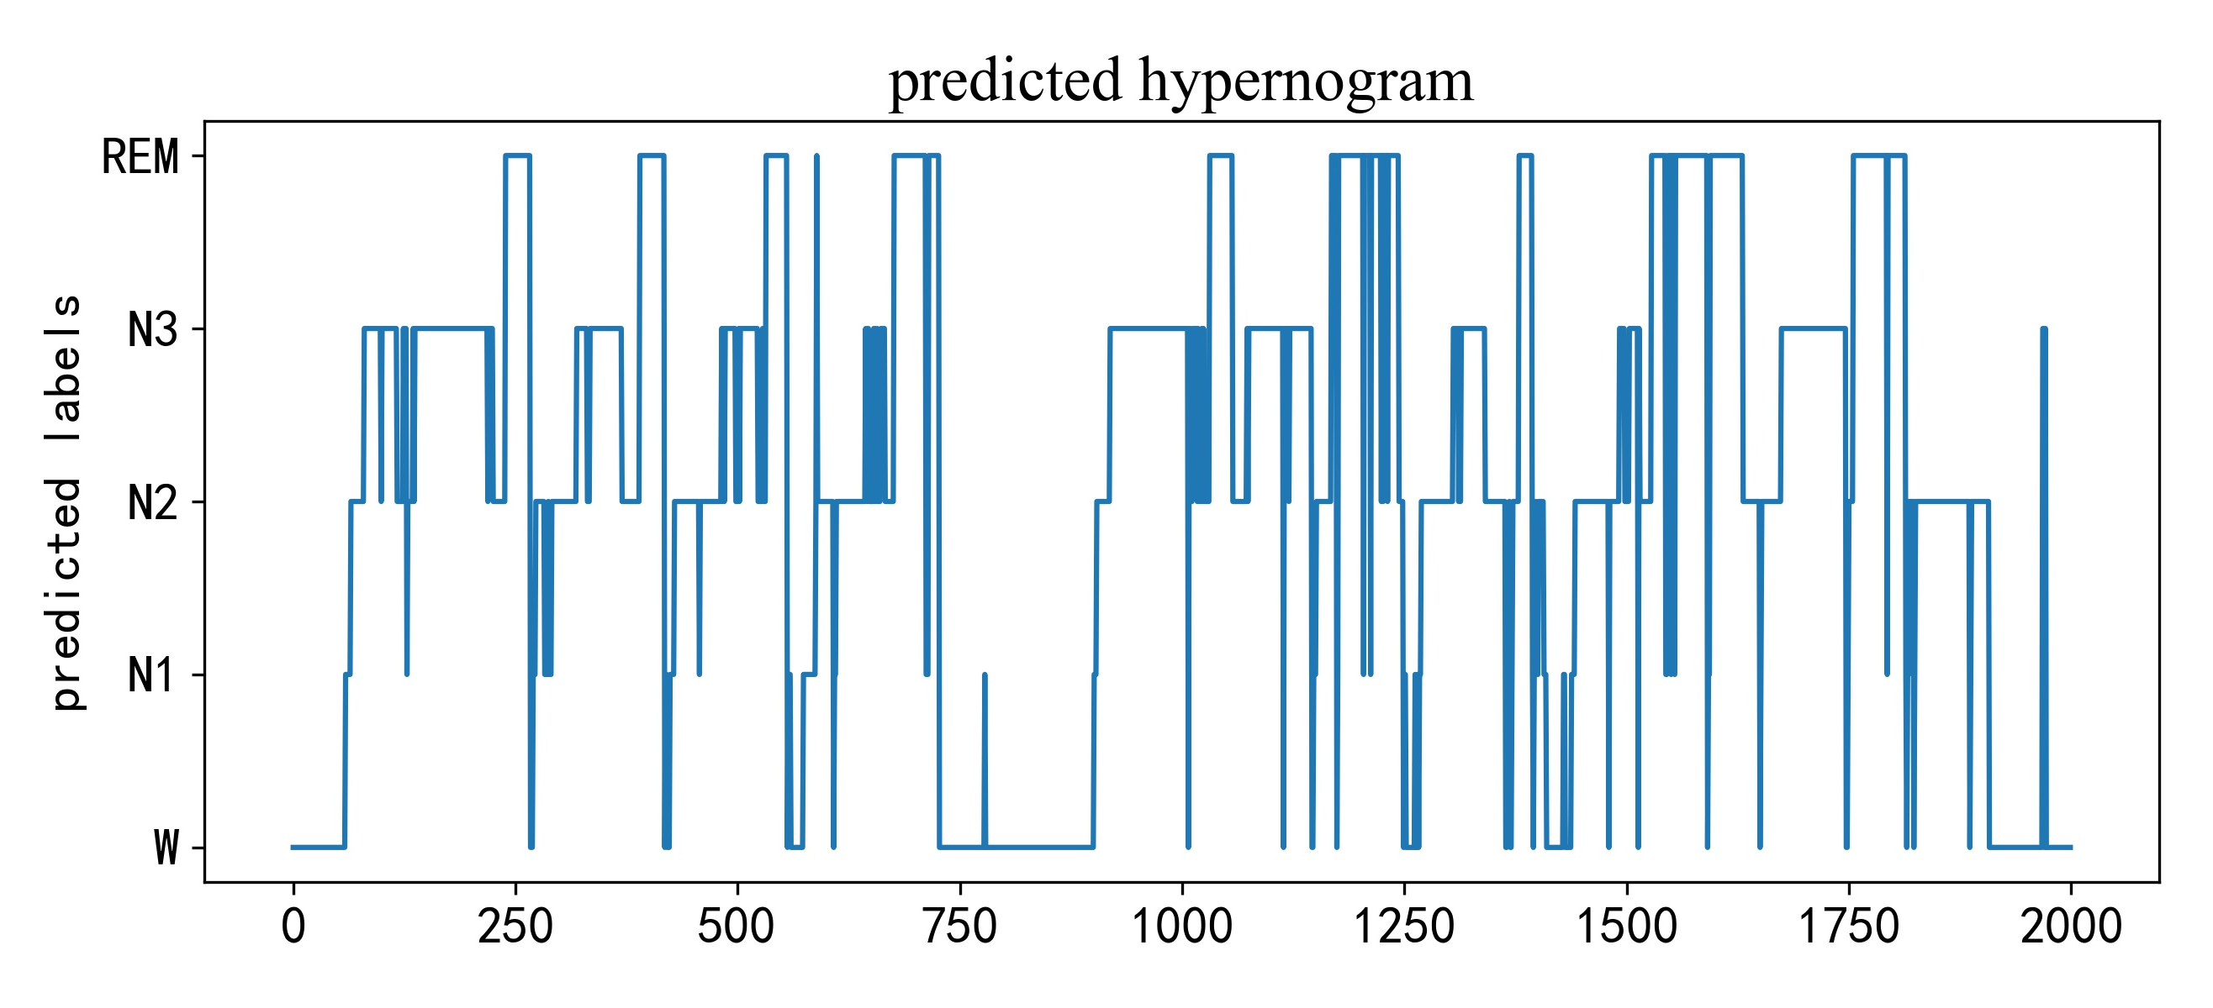
Figure 7.1
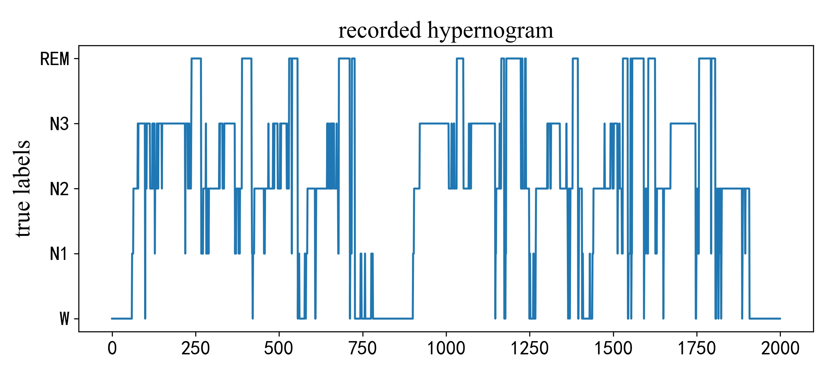
Figure 7.2

The two figures above are a comparison of predicted hypnogram and a recorded hypnogram of 2000 30-s EEG epochs. With 120 30s EEG epochs count as 1 hour of sleep. With the left is autogenerated by the hypnogram data inputs and labels, the right being produced by the predictions of the model Tiny Sleep Net.
Table of predicted confusion matrix
 | Predicted
 | W | N1 | N2 | N3 | REM
W | 8869 | 1049 | 137 | 23 | 119
N1 | 468 | 1506 | 555 | 16 | 259
N2 | 418 | 600 | 15686 | 604 | 491
N3 | 73 | 7 | 819 | 4802 | 2
REM | 311 | 751 | 1136 | 4 | 5515

Table of per-class metrics confusion matrix
 | Per-Class Metrics
 | PR | RE | F1
W | 87.5 | 87.0 | 87.2
N1 | 38.5 | 53.7 | 44.8
N2 | 85.6 | 88.1 | 86.8
N3 | 88.1 | 84.2 | 86.1
REM | 86.4 | 71.5 | 78.2

Figure 7.3 is the overall performance of the prediction made by our model from completely raw EEG signals, combined with Figure 7.1 and 7.2, collectively indicate that the main features are well learnt by the model. However, if only the N1 stage is compared with, we can clearly address that the model sacrifices the accuracy of one particular state in return to gain a more exhaustive trend globally. In other words, despite a good overall performance, the performance of the model Tiny Sleep Net is not consistent, and more importantly, can be largely affect by the unbalancing of data inputs. Although in the final predictions, the N3 stage data does not occupy the most portion of the input, N3 signals are the predominant inputs in the training set, therefore we can see the most accurate per-class prediction lies in the N3 signals.

Overall, we generated a good implementation of convolutional neural networks which distinguishes different features of EEG and categorized the five stages separately. This model automatically assigns labels via outputs from each epoch with a high rate of accuracy. The reliability is justified from the fact that it will correctly distribute an overall accuracy of 82.3% of the labels of the data regardless of the size of the data. The overfitting and imbalanced input problems are alleviated and handled using max-pooling and LSTM strategies. However, one cannot ignore that even though such a model vindicates the fact that the deep learning method can be implemented and extract features internally based on the use of neural and activation functions, the performance of the predictions is susceptible to the condition of data inputs. The model displays a profound performance if all five stage signals are equally distributed. If on the other side, there exists a situation with an insufficient amount of one particular data, the majority stages then tend to favored that the minority ones.

discussion
One major limitation we encountered during the training process is that the dataset or samples of EEG data labels for each stage are not evenly distributed, which would improve our predictions. Therefore it would let us build a more robust model. The majority stages are favored over the minority ones.
With the help of the pooling layer, the calculation and time complexity will be further reduced. The separated consecutive convolutional layers are currently driving our models to an extent that consumes more time and inconspicuous improvements. To down sampling, our interneural features that may tend to 'draw attention to some less general properties, and obtain a less complex and more performance-prioritizing model, a max-pooling layer that gathers essential features and reduces weights of less general features in sequence training would help.
As for solving the problem that the discussed approach witness a huge fall in prediction accuracy when parameters are changed, one possible solution would be conducting feature extractions to various datasets evenly.

Conclusion
From the output of predictions, autodetection that generates labels giving the EEG signals is therefore achievable. As the model determines a specific relationship between Fpz-Cz EEG waves and the level of sleep condition. This model can also be used in various experimental and pragmatic fields, such as evaluating the level of insomnia. However, consider the uncertainty of a real-world assessment of the model, the issues we found based on the deep learning method indicates that such approach sacrificed the minority stage features in favor of the majority ones, thus some important nurances of a relative minority stage may get waived automatically by this learning process. Although Tiny Sleep Net is a profound approach for auto-grading sleeping stages for sleep monitoring, a model that favors equally the major and minority stages is to be better accepted. Next, we would try to modify different parts to satisfy the above issues and thus a real-world implementation associated with this model can be expected.

References
- A. Supratak and Y. Guo, "TinySleepNet: An Efficient Deep Learning Model for Sleep Stage Scoring based on Raw Single-Channel EEG," 2020 42nd Annual International Conference of the IEEE Engineering in Medicine & Biology Society (EMBC), 2020, pp. 641-644
- U. Rajendra Acharya, Shu Lih Oh, Yuki Hagiwara, Jen Hong Tan, Hojjat Adeli,Deep convolutional neural network for the automated detection and diagnosis of seizure using EEG signals,Computers in Biology and Medicine, Volume 100,2018, Pages 270-278, SSN 0010-4825, doi:10.1016/j.compbiomed.2017.09.017.
- Alex Graves, Jürgen Schmidhuber, Framewise phoneme classification with bidirectional LSTM and other neural network architectures, Neural Networks,Volume 18, Issues 5–6,2005,Pages 602-610,ISSN 0893-6080, doi: 10.1016/j.neunet.2005.06.042.
- Google Books. 2021. EEG Signal Processing. [online] Available at: <https://books.google.com.hk/books?hl=en&lr=&id=f44hLefOz6UC&oi=fnd&pg=PT4&dq=eeg+signal+processing&ots=FuhXFrhSA-&sig=u9O4OHkFIJB3lJzITVf2Dc4G7wc&redir_esc=y&hl=zh-CN&sourceid=cndr#v=onepage&q=eeg%20signal%20processing&f=false> [Accessed 5 September 2021].
- Y.-L. Hsu et al., “Automatic sleep stage recurrent neural classifier using energy features of EEG signals,” Neurocomputing, vol. 104, pp. 105– 114, 2013.
- J. Su, D. V. Vargas and K. Sakurai, "One Pixel Attack for Fooling Deep Neural Networks," in IEEE Transactions on Evolutionary Computation, vol. 23, no. 5, pp. 828-841, Oct. 2019
- X. Zhang and D. Wu, "On the Vulnerability of CNN Classifiers in EEG-Based BCIs," in IEEE Transactions on Neural Systems and Rehabilitation Engineering, vol. 27, no. 5, pp. 814-825, May 2019
- Ahnaf Rashik Hassan, Mohammed Imamul Hassan Bhuiyan, An automated method for sleep staging from EEG signals using normal inverse Gaussian parameters and adaptive boosting, Neurocomputing, Volume 219, 2017, Pages 76-87, ISSN 0925-2312, doi：10.1016/j.neucom.2016.09.011.
- Alex Graves, Jürgen Schmidhuber, Framewise phoneme classification with bidirectional LSTM and other neural network architectures, Neural Networks,Volume 18, Issues 5–6,2005,Pages 602-610,ISSN 0893-6080, doi: 10.1016/j.neunet.2005.06.042.
- Goldberger, A., Amaral, L., Glass, L., Hausdorff, J., Ivanov, P. C., Mark, R., ... & Stanley, H. E. (2000). PhysioBank, PhysioToolkit, and PhysioNet: Components of a new research resource for complex physiologic signals. Circulation [Online]. 101 (23), pp. e215–e220.
- Physionet.org. 2021. Sleep-EDF Database Expanded v1.0.0. [online] Available at: <https://physionet.org/content/sleep-edfx/1.0.0/> [Accessed 11 September 2021].
- Z. Zhang, "Improved Adam Optimizer for Deep Neural Networks," 2018 IEEE/ACM 26th International Symposium on Quality of Service (IWQoS), 2018, pp. 1-2, doi: 10.1109/IWQoS.2018.8624183.
- 3D Context-Aware Convolutional Neural Network for False Positive Reduction in Clustered Microcalcifications Detection IEEE Journal Of Biomedical And Health Informatics 2021Jianqiu ZhengHaotian SunS. WuKe JiangYunsong PengXiaodong YangF. ZhangMing Li
- N. Papernot, P. McDaniel, S. Jha, M. Fredrikson, Z. B. Celik and A. Swami, "The Limitations of Deep Learning in Adversarial Settings," 2016 IEEE European Symposium on Security and Privacy (EuroS&P), 2016, pp. 372-387, doi: 10.1109/EuroSP.2016.36.
